Purpose

The main purpose of the lab was to help us review and remember what we had learned last year since it was our first lab of the year. It was also to help us learn how to work together and use our resources to help us when we got stuck instead of going to the teachers for help. By setting up multi-area OSPF we also learned more about how the routers communicate with each other throughout a network. We also learned how splitting them into different areas made it more efficient when it came to maintaining the routing tables and communicating with other devices within the network.

Background Information

The main concept that we covered in this lab was implementing and using multi-area OSPF to communicate across different networks through PCs and routers. OSPF is a routing protocol that finds the best available path for traffic to flow through a large network. Also, when multiple routers are set up with OSPF they can immediately send information about changes that are made as they detect them, so all the routers are on the same page. Multi-area OSPF is the same protocol, it is just a way to organize the all the different routers and PCs into groups so it is easier to read and understand. OSPFv3 is also the same as regular OSPF, it just uses a different type of addresses that are assigned to the routers and the PCs.

Lab Summary

In this lab we set up multi-area OSPF for IPV4 and IPV6 between five different routers which were connected to each other by Ethernet cables. We split the five routers into three different areas, areas 51, 17, and 0. Within the three areas we set up three separate networks and came up with both IPV4 and IPV6 addressing schemes to assign to the routers and the PCs. Setting up multi-area OSPF allowed the routers and PCs to communicate with each other, no matter what area they were in or what address they had.

Lab Commands

For this lab we already knew all of the commands that were required since the lab served mostly as a review of the things we had learned the year before. Some of the important ones included, router OSPF ipv6 router OSPF, and IPV6 unicast-routing. The router OSPF command allowed the routers to run IPV4 OSPF, after using this command we had to add network statements to tell the router where to communicate. The IPV6 router OSPF essentially did the same thing but instead of adding network statements it must be added to the interfaces that you want it to communicate out of. Also, in order for IPV6 router OSPF to work there must be IPV6 addresses on the interfaces and the IPV6 unicast-routing command, which allows the router to use both IPV4 and IPv6 addresses. Since it was multi-area OSPF instead of single area OSPF it was necessary to add which area each interface would be in after each network statement and in after the IPV6 router OSPF 1 command.

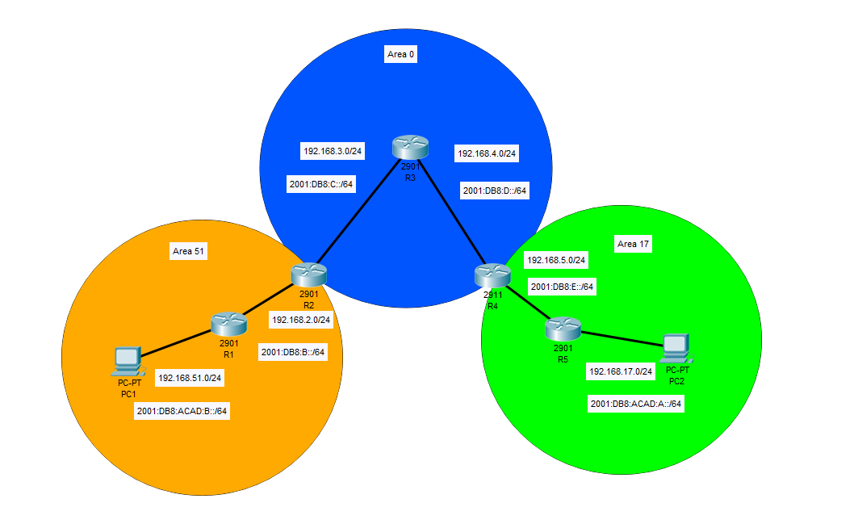Network Diagram

Problems

While trying to complete this lab we ran into some with the connections between our routers, for IPV6 OSPF we forgot to use some of the commands when we set it up. We ended up looking back to our previous notes to see what we missed and fixed the problems on the interfaces. While configuring the routers we also had errors with putting in the wrong IP addresses or misspelling commands we were able to find these and fix them quickly. Also, when we tried to ping from PC to PC the pings were getting all the way to the router in front of it but not to the PC itself. When we checked the router configurations we didn’t spot any errors and we found that we could ping all the way through. After looking over the commands multiple times and making minor changes to the configurations we decided to try restarting out PCs and after that the problem was solved. This lab wasn’t particularly challenging but we had forgotten most of the commands since it was our first lab coming back from summer break. During this lab we learned to use our resources from CCNA to help us if we are stuck or if we have forgotten what we were supposed to do.

Conclusion

For this lab we set up multi-area OSPF for IPV4 and IPV6 using three different areas so that the routers could communicate with each other. To do this, we set up three different addressing schemes for both IPV4 and IPV6 and assigned them to the PCs and the interfaces of the routers. Then we used the OSPF commands so that the routers would know where to send their traffic. Overall, the lab went well for us, we struggled a little with the IPV6 commands but were able to look back in our notes and figure out what to do so that it would function properly. Other than that, we only had small errors with our configurations that we were able to solve quickly. During this lab I learned how much I had forgotten from last year and what resources I could use that were the most helpful to solve problems since we weren’t learning the information the same way that we did when we learned OSPF the first time.